Good sample BFET notes 11/6/13
Initial IEP:
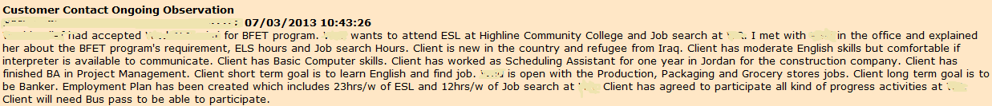
Support service & participation:
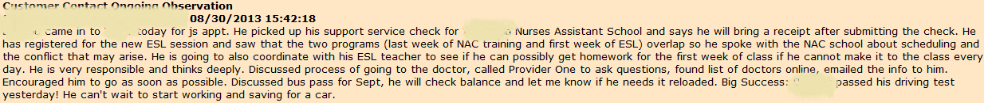
Employment:
Monthly progress:

